Development of a Fall Alarm System Based on Multi-sensor Integration

Falin Wu, Cai Hu, Hengyang Zhao and Yan Zhao
School of Instrumentation Science & Opto-electronics Engineering,
Beihang University, Beijing, China

Biography

Falin Wu is an associate professor in the School of Instrumentation Science & Opto-electronics Engineering at the Beihang University, Beijing, China. He received his PhD degree from Tokyo University of Marine Science and Technology, Japan. His current research interests are software and algorithm development for satellite navigation, GPS/GNSS signal processing, GNSS/INS integration and space geodesy.

Cai Hu is a graduate student in the School of Instrumentation Science & Opto-electronics Engineering at the Beihang University, Beijing, China. He studied at the School of University of Science and Technology Beijing and got his bachelor in 2011. His research is focused on the Ultra-tight Integration of GNSS/INS.

Hengyang Zhao is a graduate student in the School of Instrumentation Science & Opto-electronics Engineering at the Beihang University, Beijing, China. His research is focused on the application of data fusion in integrated navigation and motion tracking.

Yan Zhao is a professor in the School of Instrumentation Science and Opto-electronics Engineering at the Beihang University, Beijing, China. His current research interests are satellite positioning algorithm and technology of receiver, stable platform of imaging guidance system and detector image processing, inertial navigation system design and calibration technology.

Abstract

Due to the decline of physical fitness caused by diseases or other problems, there is a high occurrence probability of accidental falls among the older. In many cases, the injuries to the older will become much more serious as they can’t get timely help from others, some older even died. If the older wear some devices that can detect fall, and send alarm message to his/her relatives or healthcare institution, the security of the older can be ensured. This paper develops a wearable fall alarm system based on multi-sensor integration. The motion sensor is a tri-axial accelerometer, the features used to determine whether the user is fall are two kinematic parameters, and the detection algorithm is based on thresholds comparison. When a fall is detected, the system will get the user’s position from a GPS sensor, and a alarm message will be sent through the communication network. All the functions are integrated in a portable system.

Introduction

People at different ages has different probability of experiencing fall, especially the older is facing the highest probability. It’s mainly because the older always has some chronic diseases just like heart disease, hypertension, apoplexy or some nervous diseases. Beside this, some of them don’t have enough exercises, so their reaction speed, balancing capacity and sensory ability declines a lot. The elder the person is means the higher probability of experiencing fall. Some of the older who have fall may lie on the ground for a long time if they cannot get timely help. That may worsen their injuries and some of them even will die in extreme conditions. If there are some devices can detect the fall of the older, then send alarm message to his/her relatives or healthcare center, the older may get timely aid that will largely reduce the possibility of injuries worsening or death.

There are already three kinds of human’s fall detection solutions.
- Computer vision based solution: By processing digital images or videos recorded through cameras and applying some pattern recognition technologies, human’s movement can be distinguished and classified ;
- Wireless sensor network based solution: Motion sensors are placed on human’s body and measurements are transmitted to local data center through Bluetooth, ZigBee, Wi-Fi or other wireless network . The detection algorithms always work at the local data center;
- Wearable integration solution: The sensor, data processing unit and communication module is all integrated into a small kit that can be placed on human’s body .

Former two kinds of fall detection technologies or their combination can get good effect but they always need high investment (Like numeric cameras or complex wireless network) and the application range are always limited. The wearable design is low-cost and it can work effectively in outdoor situation, the usage is much more convenient.

In this paper, a wearable fall alarm system based on multi-sensor integration is developed. First, the system structure is given. Second, the fall detection algorithm is developed. Third, the hardware and software are designed. Final, several tests are conducted to validate the developed system.

SYSTEM STRUCTURE

This fall alarm system is designed as a wearable integration solution. It can detect fall of the user, get the user's position from GPS sensor and send alarm message to the user’s relatives or healthcare institution through the GSM network. The system structure and the basic working process are described in Fig 1.

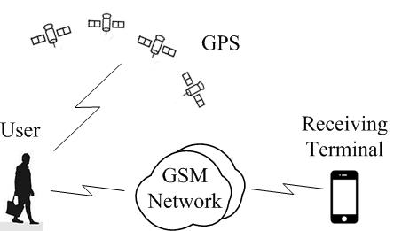
Fig 1. Structure of the proposed fall alarm system

The core of this system is the wearable detection device, it mainly consists of a data processing module, a detection sensor module, a position sensor module, a communication module as described in Fig. 2.

The data processing module is a low-cost micro-controller that manages the work of other modules and applies the fall detection algorithm. The detection sensor is a tri-axial accelerometer, which measures the user’s accelerations and sends them to the micro-controller for deep processing. The position sensor module is a low-cost GPS receiver. The communication module is based on GSM network because the system just needs short message service, and the cost of GSM network service is always cheaper than 3G or other more advance communication technologies.

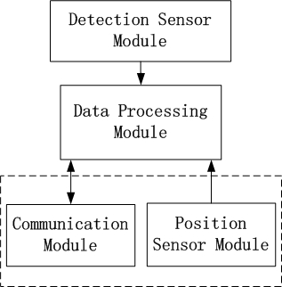
Fig 2. Structure of the detector

FALL DETECTION ALGORITHM

The device is worn on the right side of human’s waist, and the Cartesian coordinate system built by the tri-axial accelerometer is showed in Fig 3.

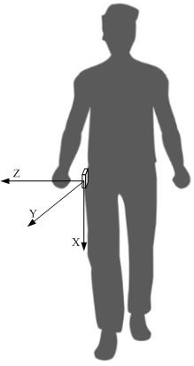
Fig 3. The wear of the detector and acceleration Cartesian coordinate system

First step to design fall detection algorithm is choosing features which can configure human’s fall and normal activities effectively. As this system uses tri-axial accelerometer as the detection sensor, accelerations in three directions and some other parameters calculated by these three measurements could be chosen as features to detect fall. There are two features used in this system. The first is the acceleration at X-axis 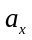, and the second is the magnitude of resultant acceleration, it’s calculated as 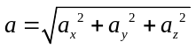.

Beside this, time domain parameters like posture angles and some frequency domain parameters can also be used as features. If more sensors like gyroscope and microphone are also used as detection sensor beside accelerometer, there will be more features can be used to detect fall. But in fact, thresholds of acceleration are quite enough to distinguish fall from normal activities.

There are already two kinds of fall detection algorithms. One is based on threshold comparison of features , just like one feature with several thresholds or numeric features with different thresholds. The other kind uses pattern recognition principle to strengthen the detection effect, technologies like support vector machine or neural network may be used . Pure threshold based algorithm is always compact, but the values of thresholds must be set prudentially. Pattern recognition could provide high success rate but it needs reasonable training and it's always too complex to be used in low-cost embedded system. So threshold based detection algorithm is much more useful for wearable device. In this system, simple threshold comparison of two features is used to apply the fall detection algorithm.

When a person is falling, he will experience mild free fall at first, then strong impact and lying on the ground . The change of feature and feature in this process is showed in Fig 4. The value of is -1g and the magnitude of equals 1g in normal condition. As has signed in Fig 4 (a) and (b), the change of and consists of five phases.
- Phase I: The magnitude decreases and produces a low peak in a short time, it’s conducted by short time of mild free fall;
- Phase II: The magnitude will experience a short time rise as a transition then produces a high peak that conducted by strong impact to the ground;
- Phase III: The magnitude will decrease but it’s still very large for a short time;
- Phase IV: The magnitude will experience a short time of rise and fall as the second transition;
- Phase V: The magnitude will close to 1g for a long time, and the will close to 0 at the same time as human will lie on the ground.

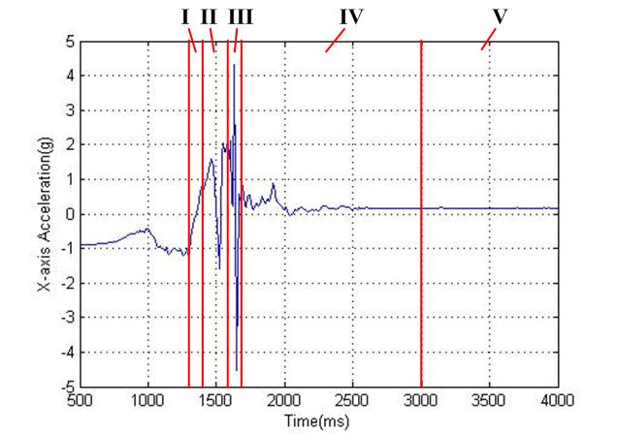
(a) Acceleration at X-axis
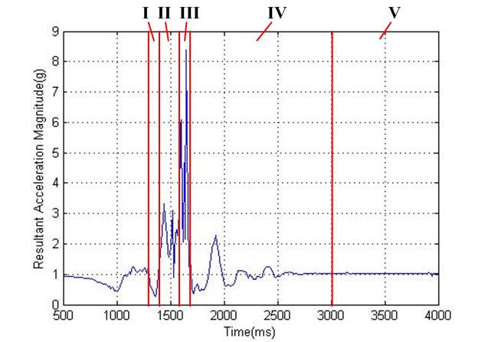
(b) Resultant acceleration magnitude
Fig 4. Signals in a typical fall process

Six acceleration thresholds and five time thresholds are used in this algorithm.
- 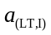: Lower threshold of in Phase I;
- 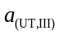: Upper threshold of in Phase III;
- 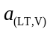: Lower threshold of in Phase V;
- 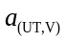: Upper threshold of in Phase V;
- 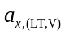: Lower threshold of in Phase V;
- 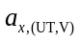: Upper threshold of in Phase V.
- 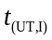: Upper time threshold of Phase V;
- 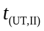: Upper time threshold of Phase II;
- 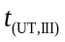: Upper time threshold of Phase III;
- 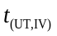: Upper time threshold of Phase IV;
- 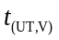: Upper time threshold of Phase V.

The detection algorithm is applied by a state machine. There are five states in this algorithm correspond to five phases in human's fall as described below. Flow diagram of the state machine is showed in Fig. 5. There are two marks 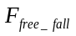 and 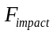 used in the algorithm. Mark 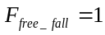 means has experienced free fall process, and 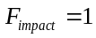 means has experienced impact process.
- FREE_FALL: State corresponds to Phase I;
- IMPACT: State corresponds to Phase III;
- TRANSITION: When and 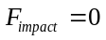, the state corresponds to Phase II. When and , the state corresponds to Phase IV;
- INACTIVITY: When 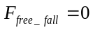 and, the state means is between and , it's in a normal state. When and, the state corresponds to Phase V, it means accords with the same condition and is between and at the same time. The algorithm begins in state INACTIVITY with and . If , and 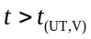 at the same time, it means a fall has been detected;
- ACTIVITY: It corresponds to none of the five phases.

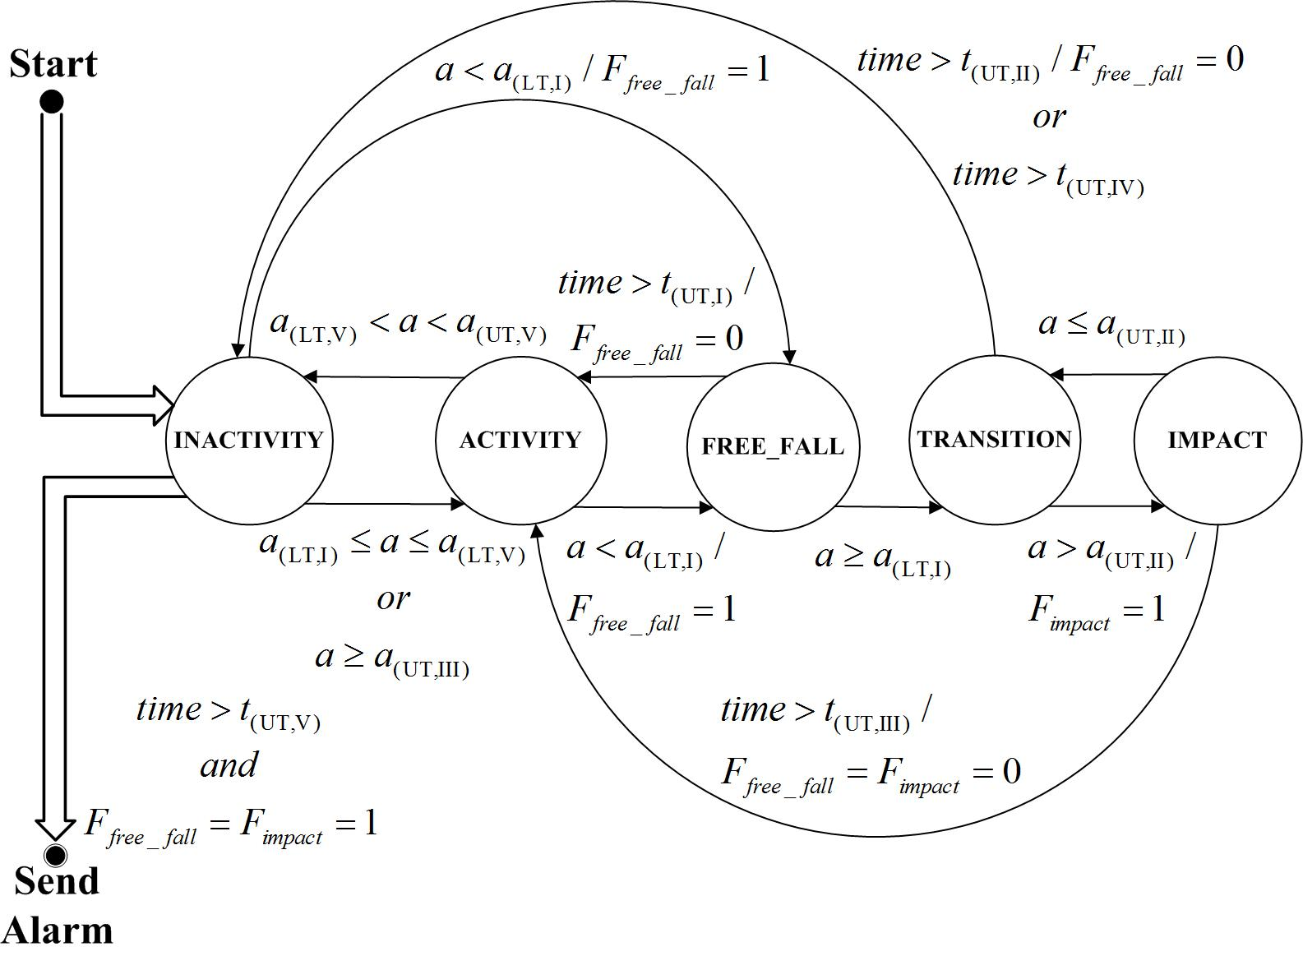
Fig 5. State diagram of the fall detection algorithm

HARDWARE IMPLEMENTATION

Micro-controller in this system is TI's 16 bits MSP430F1611 . The detection sensor is ADI’s digital tri-axial accelerometer ADXL345 . The GPS and GSM function are integrated in SIMCom's SIM908 module .

Features of ADXL345 such as sampling rate and measuring range fit the need of human’s fall detection. As there is an inner digital filter in ADXL345, noise in the measurements is somewhat weakened. So the measurements are transmitted to micro-controller without extra processing through I²C interface.

SIM908 offers two independent serial interfaces for GPS and GSM function. Both of them are connected to MSP430F1611’s two serial interfaces.

As each of the hardware modules in this system is working under lower voltage and the program could work in low power mode, the whole power consumption will be quite low. A 3.7V lithium battery is quite enough to afford the power requirement. So this system is very suitable for wearable use.

Whole PCB board is showed in Fig 6. Main modules of the detector are all signed on the figure.

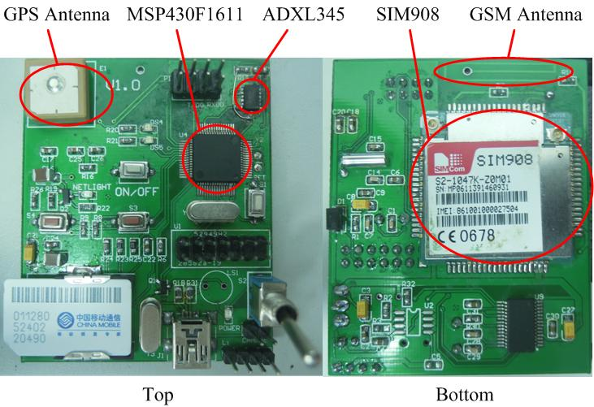
Fig 6. PCB board of the detector

SOFTWARE IMPLEMENTATION

Program's working diagram is described in Fig 7.

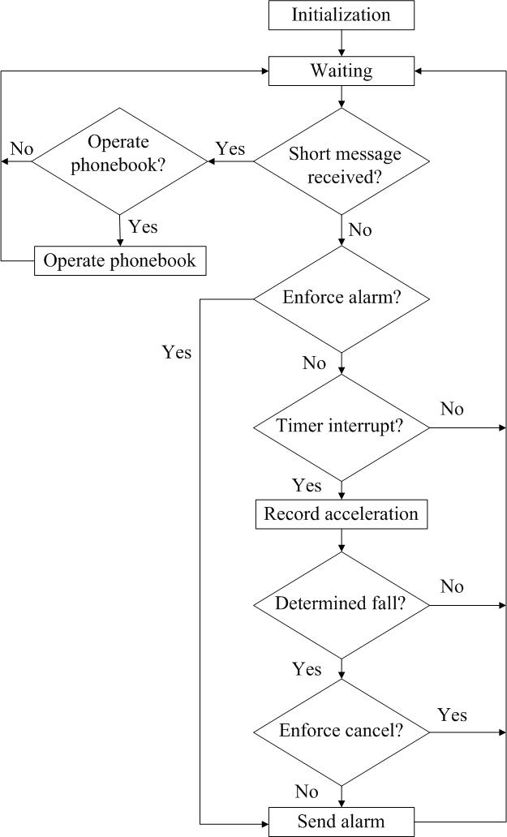
Fig 7. Program flow diagram

After the system is powered on, the initialization will be done at first. Then program will enter low power mode to reduce power consumption. It will recover normal working mode only if system has received a short message, a timer interrupt is coming or manual operation has been activated.

Measuring, calculating and detection algorithm all work in Micro-controller’s timer interrupt service. Sampling rate is set at 100Hz, that’s larger than twice of human’s highest motion frequency (Shannon principle). Program then will calculate resultant acceleration a, and enter the detection algorithm. If a fall is detected, system will get the user’s position information through GPS and send alarm short message. Both of them are based on serial operation, and the speed is set at a baudrate of 115,200bps.
Phonebook is designed on MSP430F1611’s flash. Operation of adding new phone number or delete phone number is realized by receiving short message with special content.

Manual operation is used to increase the system’s reliability in some special condition. If the user falls but system cannot recognize it, the user can send alarm short message by pressing a button. If the system recognized user’s normal activity as fall, the user can stop it also by pressing a button. In third condition, if the system detect user’s fall correctly, the user also can decide whether to send the alarm short message.

SYSTEM TEST

Each part of the system hardware could work as requirements in careful tests. The thresholds in the algorithm are set based on an experiment. The whole system could work normally and typical falls can be detected. Fig 8 shows the alarm short message has been transmitted from the fall detection system.

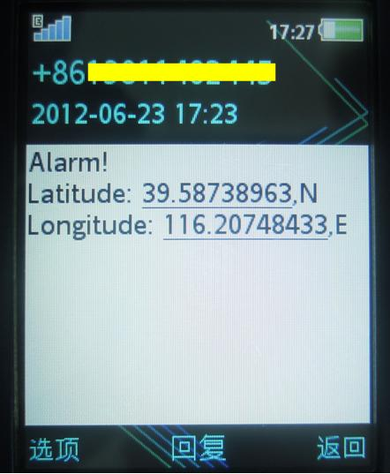
Fig 8. Alarm message sent by the system

In order to find appropriate thresholds and validate the algorithm’s performance, an experiment was made. Participant in the experiment is a young male (177cm height, 58kg weight). The experiment contains four kinds of fall types (forward fall, backward fall, leftward fall and rightward fall), each kind 10 times. Besides this, five kinds of activities of daily living (ADL, including walking, jumping, squatting, sitting and lying) are also tested, each kind five times.

Signals in different type of falls are quite similar. Fig 9 shows the signal in leftward fall. Fig 10 to Fig 14 show signals in walking, jumping, squatting, sitting and lying.
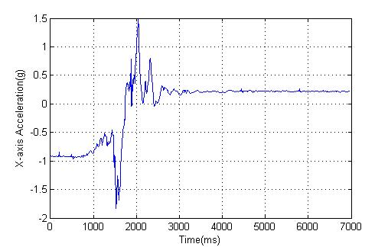
(a) Acceleration at X-axis
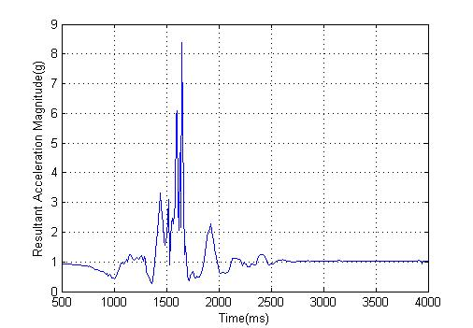
(b) Resultant acceleration magnitude
Fig 9. Signals in process of leftward fall

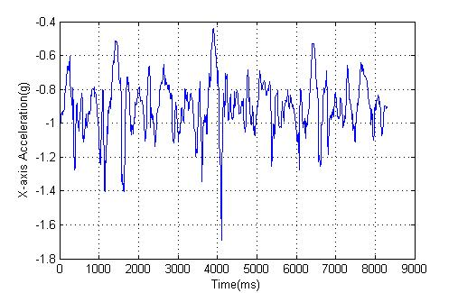
(a) Acceleration at X-axis
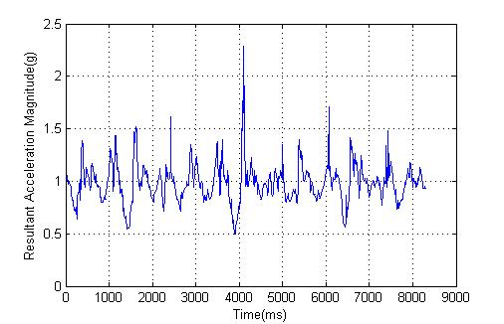
(b) Resultant acceleration magnitude
Fig 10. Signals in process of walking

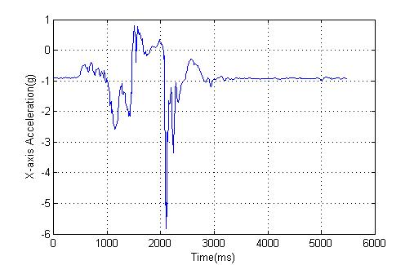
(a) Acceleration at X-axis
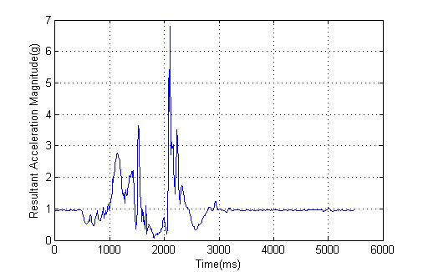
(b) Resultant acceleration magnitude
Fig 11. Signals in process of jumping

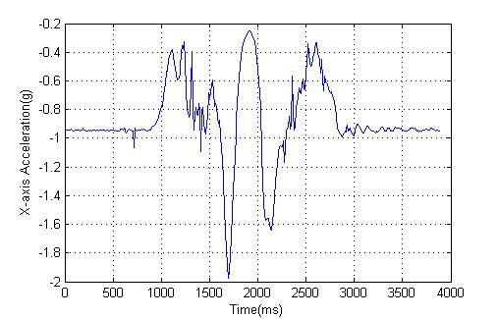
(a) Acceleration at X-axis
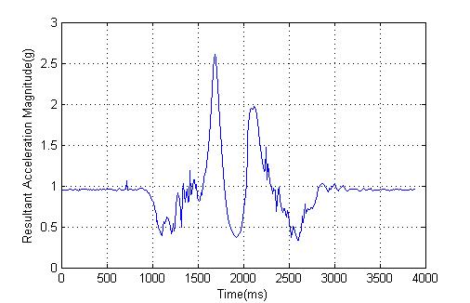
(b) Resultant acceleration magnitude
Fig 12. Signals in process of squatting

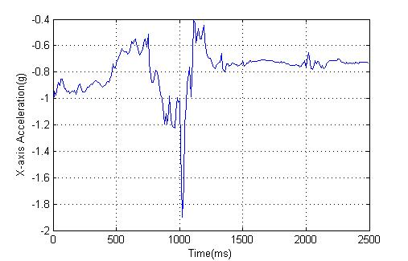
(a) Acceleration at X-axis
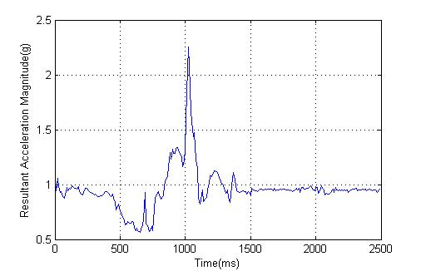
(b) Resultant acceleration magnitude
Fig 13. Signals in process of sitting

(a) Acceleration at X-axis
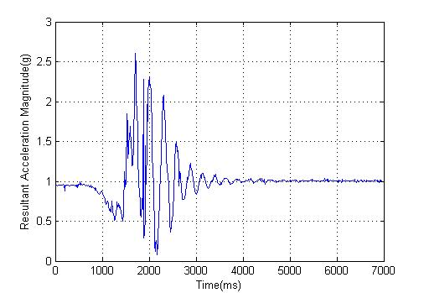
(b) Resultant acceleration magnitude
Fig 14. Signals in process of lying

Signals of may be similar between fall and some normal activities like walking, jumping, squatting and sitting , but feature is obviously different between them.

Recognition rate of each kind of motion is summarized in Table. 1. Recognition of fall means proportion of correct detection and it means proportion of not detected as fall for ADL.

Table 1. Recognition rates of different kind of motions in the experiment
Motion Type | Recognition Rate (%)
Forward Fall | 90
Backward Fall | 100
Leftward Fall | 90
Rightward Fall | 90
Walking | 100
Jumping | 100
Squatting | 100
Sitting | 100
Lying | 80

But as human’s body will at last be horizontal when lying, could not distinguish fall and lying. In this condition, the use of feature is very important. The upper peak of in fall differs from lying because fall is often uncontrolled, the upper peak will be higher than lying. So proper setting of thresholds in the algorithm is the key of the system's performance.

CONCLUSION

This paper developed a wearable fall alarm system based on multi-sensor integration. A single tri-axial accelerometer in this system can afford the requirement of the older fall detection. As the system is wearable and has low power consumption, it’s quite convenient to use and work in outdoor situation for a long time. The GPS technology can provide accurate position information and short message service based on GSM network has high reliability. What’s more, other functions like manual operation make this system much more flexible in some special situations.

In order to enforce the system’s robustness, experiment which is more rigorous is necessary. The type of motion should be abundant, special motion like heavy lying and light fall must be considered. Number of participants and their physique should be chosen properly and it’ll be better with participation of the older. Test number of each motion type also should be large enough to get better statistical result.

ACKNOWLEDGMENTS

The research is partial supported by the Scientific Research Foundation for the Returned Overseas Chinese Scholars, State Education Ministry, and the Specialized Research Fund for the Doctoral Program of Higher Education, China.

REFERENCES

